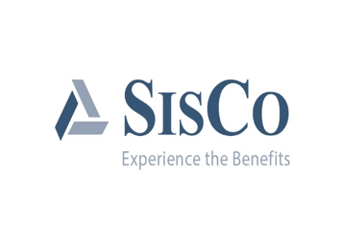

2019 Flexible Spending Enrollment Packet

Welcome to the flexible spending plan with SISCO! We look forward to assisting you in navigating the reimbursement plan you elected.

### Table of Contents

Definitions…………………………………………………………………………………………………..1

Advantages of a Flexible Spending Account………………………………………………….2

Frequently Asked Questions…………………………………………………………………………3

General Reimbursement Guidelines……………………………………………………………..4

Eligible and Non-Eligible Expenses………………………………………………………………..5

Eligible Expenses……………………………………………………………………………..…5

Over the Counter Medication and Drugs………………………………………………5

Dental Expenses…………………………………………………………………………………6

Potentially Eligible Expenses……………………………………………………………….6

Non-Eligible Expenses…………………………………………………………………………6

Instructions for filing a Flexible Spending Claim……………………………………………7

Supporting Documentation for medical reimbursement………………………7

Supporting Documentation for dependent care reimbursement………..…7

Accessing the Benefit Information Network………………………………………………….8

Flexible Spending Election Form…………………………………………………………………10

Flexible Spending Reimbursement Request Form……………………………………...11

Flexible Spending Dependent Care Contract……………………………………………….12

Direct Deposit Authorization Form……………………………………………………………..13

**Definitions**

**Flexible Spending Plan**

IRS Section 125 (Flexible Spending Reimbursement) is available to you as an employee benefit. Flexible spending allows you to pay for certain expenses through a pre-tax payroll deduction which can result in *significant* tax savings. Please be aware if the scheduled processing day falls on a holiday or weekend your claims will be processed one business day prior. Plan your flex submissions accordingly.

**Medical Reimbursement**

Your medical/dental reimbursement plan will allow you to pay for out-of-pocket expenses with pre-tax dollars. For any tax-deductible health care expenses not covered by a health plan or other insurance, you simply complete a Flexible Spending Claim Form, attach the appropriate bills/receipts or explanation of benefits from your other insurance carrier, and send it to SISCO.

**Dependent Care Reimbursement**

Your dependent care expense plan allows you to pay for expenses that are incurred for the care (daycare, babysitting) of a qualifying dependent, or for related household services and are incurred for you to be gainfully employed. Submit a claim form for dependent care expenses actually incurred and you will be reimbursed from your Flexible Spending Account with pre-tax dollars that were deducted from your payroll.

*The IRS requires that Form 2441 be filed with your Federal Income Tax Return, if you participate in a dependent care plan, listing the providers name, address, and social security or tax I.D. number.*

**Automatic Rollover**

If you are enrolled in your company's health plan administered by SISCO, claims will automatically be reimbursed for ineligible health plan expenses, deductibles, and any copayments with your Flexible Spending Account for these expenses to rollover automatically without filing a separate flexible spending claim. You need only to elect the Automatic Payment Authorization Section once each year to receive reimbursement. Do not sign up for automatic rollover if you have coverage under more than one plan.

**Grace Period**

The Plan will allow expenses incurred during a “grace period” to be reimbursed from contributions for the current Plan Year. The “grace period” will be 2½ months, beginning on January 1 of the year following the current Plan Year and ending on March 15 of that year. For example, for the Plan Year January 1, 2019 through December 31, 2019, any eligible expenses incurred between January 1, 2019 and March 15, 2020 may be reimbursed from contributions remaining from the 2019 Plan Year. All claims for reimbursement must be filed on or before the 90th day following the close of the Plan Year.

**Advantages of a Flexible Spending Account**

A Flexible Spending Account (FSA) allows you to save up to 30% on your eligible healthcare and/or dependent care expenses every year by using pre-tax dollars. Consider how much you spend on healthcare and/or dependent care expenses for you and your qualified dependents in one year:

• Prescription drugs/medications

• Medical/dental office visit co-pays

• Eye exams and prescription glasses/lenses

• Vaccinations

• Daycare tuition

By using pre-tax dollars, you are taxed on a lower gross salary, thereby saving money that would otherwise be spent on federal, state and FICA taxes, and thereby you increase your take home pay.

|  |  |  |  |  |  |
| --- | --- | --- | --- | --- | --- |
| **Estimated Tax Savings** | | | | | |
|  | Not Enrolled in FSA |  | Enrolled in FSA |  |  |
| Gross pay | **$38,000.00** |  | **$38,000.00** |  | **Gross pay** |
|  |  |  |  |  |  |
| FSA Contribution | **$0.00** |  | **$2,650.00** |  | **Pre-tax flex dollars** |
|  |  |  |  |  |  |
| Taxable Income | **$38,000.00** |  | **$35,350.00** |  | **Lower taxable income** |
|  |  |  |  |  |  |
| 15% Federal taxes | **($5,700.00)** |  | **($5,302.50)** |  | **15% Federal taxes** |
|  |  |  |  |  |  |
| 4% State taxes | **($1,520.00)** |  | **($1,414.00)** |  | **4% State taxes** |
|  |  |  |  |  |  |
| 7.65% FICA tax | **($2,907.00)** |  | **($2,704.28)** |  | **7.65% FICA tax** |
|  |  |  |  |  |  |
| Medical expenses | **$2,650.00** |  | **$0.00** |  | **Paid with FSA** |
|  |  |  |  |  |  |
| Take-home Income | **$25,223.00** |  | **$25,929.23** |  | **Take home increases by $706** |
| *Individual state taxes will vary by states.* |  |  |  |  |  |

Based on the above graph, adding a flexible spending account can increase your net take-home pay by $706. (This is for illustration only. Actual dollar amounts may vary.)

**Frequently Asked Questions**

**What is the benefit of participating in a flexible spending plan?**

By signing a participating agreement, you agree to have your salary reduced by the agreed upon amount. Therefore, you are not responsible for federal income tax withholding or FICA on the amount of the reduction, thereby saving you 7.65% on FICA, plus whatever income tax you would be obligated to pay on this amount. While it's true that you forfeit unused money from your flexible spending account, you can still come out ahead even if you don't use all the money in your account.

**When do I make my election?**

You need to make your election during open enrollment at your employer. This usually occurs once per year prior to the start of the new plan year. The start of the plan year may vary.

**Can I change my benefit election mid-year?**

Changes can be made due to the qualifying events listed below and must be made within 31 days of the event. You may change your reimbursement election if you were enrolled in the plan prior to the qualifying event and you wish to change your election.

**Medical reimbursement** **accounts** can be changed with a qualifying event (i.e. marriage, divorce, death or a spouse or child, birth or adoption of a child, termination of employment of your spouse, or a change in work schedule).

**Dependent care reimbursement** **accounts** can be changed with a qualifying event (i.e. birth or death of a child, adoption of a child, dependent is no longer eligible for daycare, change in employment status thus changing the need for daycare, changing daycare providers, or a cost increase or decrease in daycare).

**What happens if my reimbursement request exceeds the balance in my account?**

Your medical reimbursement account claims will be paid in full, up to the annual amount you have elected to have withheld for that plan year.

Dependent care reimbursement account claims will be processed and paid up to the balance in your account. If your claim exceeds that balance, SISCO will automatically reprocess your claims as your balance allows.

***Please note:*** *the medical reimbursement account is separate from the dependent care account. Balances cannot be transferred from one account to the other.*

**What happens to the money in my account if I should terminate employment?**

You would be entitled to reimbursement for expenses which were incurred within the same plan year and before your termination date.Your plan allows you to submit claims up to 180 days after termination in the plan.

**When can I incur claims?**

Your plan year allows you to incur claims from January 1, 2019 through March 15, 2020 because your plan has elected a voluntary extension known as grace period.

**What happens to any money left over at the close of the plan year?**

The Plan will allow expenses incurred during a “grace period” to be reimbursed from contributions for the current Plan Year. The “grace period” will be 2½ months, beginning on January 1 of the year following the current Plan Year and ending on March 15 of that year. For example, for the Plan Year January 1, 2019 through December 31, 2019, any eligible expenses incurred between January 1, 2019 and March 15, 2020 may be reimbursed from contributions remaining from the 2019 Plan Year.

**What is the filing deadline for claims submission?**

You have 90 days to submit claims at the end of the plan year. The last day to submit claims is March 31, 2020.

**General Reimbursement Guidelines**

* Reimbursement is not a guarantee without the correct documentation.
* Reimbursement of dependent care expenses will reduce and may eliminate your ability to claim dependent care credit on your Federal Tax Return.
* Health care expenses reimbursed through this account cannot be deducted on your Federal Income Tax Return.
* Expenses can only be submitted for reimbursement if they were for you or for eligible dependents under the plan.
* Only the expenses for services or supplies furnished on or after the effective date of the plan can be submitted for reimbursement.
* Reimbursement of expenses should only be requested and made after you have collected all benefit payments available for all other insurance plans under which you and your eligible dependents are covered.
* Reimbursement will be made in accordance with the provisions of the plan. You accept responsibility for the proper treatment of benefits paid under this plan with respect to eligibility, income tax reporting and liability.

**Eligible and Non-Eligible Expenses**

Under the Plan, you will be reimbursed only for those types of medical expenses normally deductible on your federal income tax return (without regard to the 1% and 5% of adjusted gross income limitations).

*This is a list of common reimbursable and non-reimbursable items under Section 502 of the Internal Revenue Code. This does not constitute legal or tax advice. For specific questions please see your plan administrator.*

Eligible Expenses

|  |  |
| --- | --- |
| Acupuncture | Infertility Treatments |
| Artificial Limbs | Insulin |
| Bandages | Lactation Expenses (Breast Pump, etc.) |
| Birth Control/ Contraceptive Devices | Laser Eye Surgery |
| Birthing Classes/ Lamaze | Legal Sterilization |
| Blood Pressure Monitor | Mileage to and from doctor appointments ($0.18 per mile) |
| Chiropractic | Nasal Strips |
| Contact Lenses | Orthopedic Inserts |
| Contact Solution | Physical Therapy |
| Co-Payments | Pregnancy Test |
| Crutches | Prescription Medication |
| Deductible/ Co-Insurance | Reading Glasses |
| Diabetic Supplies | Services Connected with Donating an Organ |
| Eye Exams | Sleep Apnea Services/ Products |
| Flu Shots | Smoking Cessation Programs |
| Glasses/ Safety Glasses (Prescription Only) | Treatment for Alcoholism or Drug Addiction |
| Hearing Aids and Aid Batteries | Vaccinations |
| Heating Pad | Wrist Supports |
| Incontinence Supplies |  |

Over the Counter Medication and Drugs  
(Require a prescription or letter of medical necessity from your physician)

|  |  |
| --- | --- |
| Pain Relieving Creams or Gels | Indigestion or Anti-Acid Relievers |
| Calamine Lotion | Laxatives |
| Canker/ Cold Sore Relievers | Nicotine Patch or Gum |
| Cold Medications | Pain Relievers |
| Diaper Rash Cream | Sinus Medications |
| Gas-X/ Baby Gas Drops | Suppositories |
| Hemorrhoid Creams and Treatments | Teething Gel |
| Hydrogen Peroxide or Rubbing Alcohol | Wart Removal Medications |

Dental Expenses

|  |  |
| --- | --- |
| Braces/ Orthodontic Services | Dental Implants |
| Cleanings | Dentures/ Adhesives |
| Crowns | Fillings |
| Deductible/ Co-Insurance |  |

Potentially Eligible Expenses  
(These expenses are eligible only when incurred to a treat a medical condition. These expenses will require a Letter of Medical Necessity from your provider that will need to be submitted with your reimbursement request)

|  |  |
| --- | --- |
| Ear Plugs | Support Hose |
| Massage Treatments | Varicose Vein Treatment |
| Nursing Services | Veneers |
| Orthopedic Shoes | Wigs (When hair loss is due to a disease) |
| Oxygen and Equipment |  |

Ineligible Expenses

|  |  |
| --- | --- |
| Adoption Fees | Hand Sanitizer |
| Athletic Mouth Guards | Health/ Athletic club fees |
| Auto Insurance providing Medical coverage | Illegal Treatment or Medication |
| Child or newborn care instruction | Insurance Premiums |
| Cosmetic Procedure/ Surgery | Late payment fees |
| Cosmetic Supplies | Long term care services |
| Counseling (marriage) | Lotion or skin moisturizers |
| CPR Classes | Mattress |
| Deodorant | Medicare Premiums |
| Dental Floss | Missed appointment fees |
| Denture Cleaner | Non-prescription safety glasses |
| Diapers/ Diaper Services | Non-prescription sunglasses |
| Diet Foods | Nursing Home care |
| Dietary and Fiber supplements | Oral Care (over the counter), Chapstick |
| Distilled Water | OTC Drugs/ medications without a prescription |
| Education Classes | Personal use items (Pillows, shampoo, etc.) |
| Disaster Survival Kit (Non-Emergency) | Private Hospital Rooms |
| Exercise Equipment | Toiletries |
| Eye drops for comfort | Toothbrush/Toothpaste/Teeth Whitening |
| Eyeglasses case | Vitamins/ Supplements / Herbal Supplements |
| Hair Re-growth products/ Hair Removal | Weight Loss drugs/ programs for general well being |

# Instructions for filing a Flexible Spending Claim

To submit a claim for processing, fill out a reimbursement form. This form is available online at [www.SISCOBenefits.com](http://www.SISCOBenefits.com) or by contacting our customer service department. The form must be signed and dated. Mail the completed form and attachment(s) to the address indicated on the reimbursement form.

## Supporting Documentation for medical reimbursement

Documentation of the expense is required with the claim form. According to the IRS guidelines, the expense must process through all available health plans before reimbursement under a flexible spending plan is allowed. Here are two examples of approved documentation. A canceled check is not considered acceptable evidence.

**Explanation of Benefits (EOB):** This is the form you receive from your insurance company each time a claim is submitted to your health, dental, or vision care plan. The EOB will show the amount of expenses paid or denied by the plan and the amount you must pay. For all health care expenses that are partially covered by health, dental, or vision plans, you must attach an EOB.

**Receipts:** Claims for medical/dental expense not covered by your group health plan cannot be processed without acceptable evidence of the expenses. Acceptable evidence includes receipts, which contain the following information:

* Description of service or supply
* Date expense was incurred
* Person or organization providing service
* Amount of expense
* Name of person (family member) for whom the service(s) were provided for

## Supporting Documentation for dependent care reimbursement

Documentation of the expense is required with the claim form.

**Receipts:** Acceptable evidence includes receipts, which contain the following information:

* Date expense was incurred
* Amount of expense
* Person or organization providing service (need tax ID or provider signature)
* Name of person (family member) for whom the service(s) were provided for

**Accessing the Benefit Information Network**

# How To Register As A New User

1. Access the Benefit Information Network at [www.siscobenefits.com](http://www.siscobenefits.com) and click on BIN Login.
2. Click on the Register new User button if you have not already signed up.

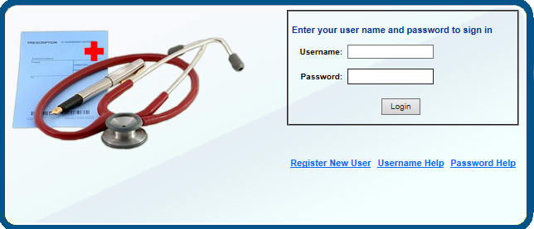

1. Enter your desired User ID and Password, and then enter your password again in the “Verify Password” section. If you are the person with the insurance coverage, you are the **SUBSCRIBER.** Click on the “I am the subscriber” button to continue.

NOTE: If you have someone else who has insurance coverage under your plan that person can also create a User ID and Password, but they would click on the button that states, “I am a dependent of the subscriber”.

1. Create your account by filling in the required data, which includes:
   * Your participant ID (this the SSN of the employee)
   * Your last name (not case-sensitive)
   * Your zip code
   * Your date of birth
   * Email address and password hint are not required fields, but are extremely useful in the situation where you forget your user name and/or password.
2. Once you have registered successfully, you will see different tabs at the top of the page. Flexible Spending account information is under Status 🡪Reimbursement Accounts.

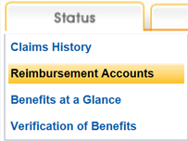

1. You will see different areas that include a summary of your account, claim activity and contribution history. The summary will show any claim amount processed, rollover amounts and remaining annual pledge.

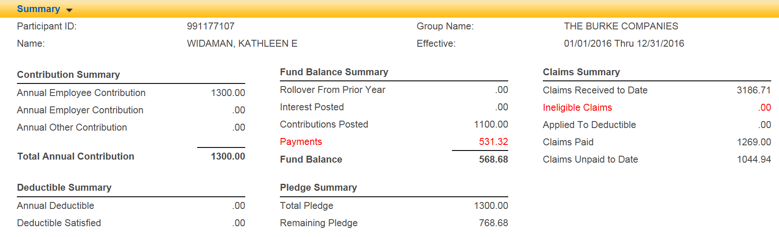

1. The Activity Detail will show any contributions and/or claims submitted.

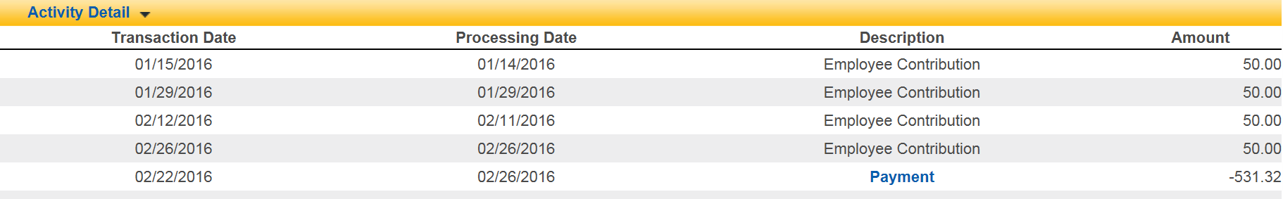

1. The Contribution History will show all contributions into the account.



Contact SISCO with any questions at 1-800-457-4726 Monday – Thursday 7:00 a.m. to 7:00 p.m. and Friday 7:00 a.m. to 5:00 p.m. You can also email us at [SISCOFlex@SISCOBenefits.com](mailto:SISCOFlex@SISCOBenefits.com).

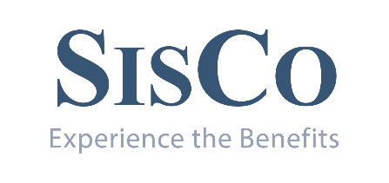

**Flexible Spending Election Form**

University of Dubuque 012

January 1 2019 through December 31 2019

Plan Year 2019

|  |  |  |  |  |  |
| --- | --- | --- | --- | --- | --- |
| **Section I - Employee Information** | | | | | |
| Employee-Last Name First Name Initial | | | Date of Birth | Social Security Number | |
| Street Address | City | | | State | Zip Code |
| Type of Election:  Annual Election  New Hire  Family Status change * see below  Explanation for change in Family Status  Effective date of this election (date of first paycheck with flexible spending reduction)  Pay Period: Bi-weekly/ monthly | | | | | |
| **Section II - Flexible Spending Agreement** | | | | | |
| I hereby elect to have my salary reduced and a corresponding amount credited to my account in the elected plan(s) below. Any changes made through a qualifying event will be effective on the qualifying event date. I have read and understand the Summary Plan Description.  I agree to notify the Company if I have reason to believe that any medical care expense for which I have obtained reimbursement is not a qualifying expense. I also agree to indemnify and reimburse the Company on demand for any liability it may incur for failure to withhold federal and state income tax or Social Security tax from any reimbursement I receive on any non-qualifying expenses. | | | | | |
| **Section 125 agreement:**   * I authorize to have my premium contribution(s) for Medical and Dental Health (if any) withheld prior to taxes as provided in Section 125. | | | | | |
| **Medical/Dental Election:**   * I authorize that my earnings be reduced in the amount of $__________ (12, 26 deductions) for other medical/dental expenses, for a yearly contribution of $ __________ ($2700 maximum- Subject to IRS Guidelines).   **Automatic Rollover:**   * I elect to have any charges processed through the University of Dubuque Health Plan to have any eligible amount to automatically roll to the University of Dubuque Flexible Spending Plan for reimbursement from my account. | | | | | |
| **Dependent Care Election:**   * I authorize that my earnings be reduced in the amount of $__________ (12, 26 deductions) for dependent care expenses, for a yearly contribution of $ __________ ($5000 maximum). | | | | | |
| Employee's Signature Date | | Accepted by Date | | | |
| **Section III - Declining Flexible Spending Coverage** | | | | | |
| I hereby waive participation in the University of Dubuque Flexible Spending Account Plan for 2019. I understand I will not be able to elect participation until the new plan year begins. | | | | | |
| Employee's Signature Date | | Accepted by Date | | | |



**Flexible Spending Reimbursement Request Form**

Participant Name:_________________________ Date of birth:_________________________

Participant ID#:_______________________________Group #:_____________________________

**MEDICAL/DENTAL/VISION EXPENSES -- ATTACH EOBS OR RECEIPTS TO CLAIM FORM**

|  |  |  |  |  |
| --- | --- | --- | --- | --- |
| **Item** | **Dependent Name** | **Date(s) of Service** | **Provider (Person or Business)** | **Reimbursement Requested** |
| 1 |  |  |  |  |
| 2 |  |  |  |  |
| 3 |  |  |  |  |
| 4 |  |  |  |  |
| 5 |  |  |  |  |
| 6 |  |  |  |  |
| 7 |  |  |  |  |
| 8 |  |  |  |  |

**DEPENDENT CARE -- ATTACH EOBS OR RECEIPTS TO CLAIM FORM**

|  |  |  |  |  |
| --- | --- | --- | --- | --- |
| **Item** | **Dependent Name** | **Date(s) of Service** | **Provider (Person or Business)** | **Reimbursement Requested** |
| 1 |  |  |  |  |
| 2 |  |  |  |  |
| 3 |  |  |  |  |
| 4 |  |  |  |  |

I hereby certify that:

* The information given on this reimbursement form is complete and accurate.
* I have not previously received reimbursement for these expenses from this Flex account or from any other source.
* All health/daycare expenses listed above comply with the requirements and guidelines listed in the Flexible Spending Packet

Signature___________________________________________ (Date) __ ___/_____/______

KEEP A COPY FOR YOUR FILES

Mail: Flexible Spending Dept., SISCO, P.O. Box 389, Dubuque, IA 52004-0389

Fax: 563-587-5703 Email: [siscoflex@siscobenefits.com](mailto:siscoflex@siscobenefits.com)

*Claims must be received at SISCO, two (2) business days before your scheduled flexible spending run.*



Flexible Spending Dependent Care Contract

*This form is being submitted to establish that a contract for services exists between me and the individual/entity who has signed below in which I have agreed to purchase dependent care services for the period indicated. A new contract is required each year.*

Participant Information

Employee Name: SSN#:

Address:

City: State: Zip:

Day Care Contract

My Contract Year will begin on______________________, and will end on______________________.

Provider’s Name:

I/We agree to provide day care services for the above mentioned employee. This service will be provided on the following basis:

|  |  |  |  |  |
| --- | --- | --- | --- | --- |
| **Time Period** |  | **Frequency** |  | **Rate of Pay** |

______________AM Daily $___________Hourly

To Weekly $___________Daily

_______________PM Monthly $___________Weekly

Based on the above schedule, it is anticipated that the above mentioned employee will incur fees which will total, during the period stated above, a minimum of: $ (per year)

Provider’s Signature Date

Title

Provider’s SSN# OR EIN#

***If the terms of this contract were to change at any time, you will need to contact us.***



**Direct Deposit Authorization Form**

Automatic Direct Deposit of your FSA reimbursements is a convenient feature that many employees take advantage of that will save time for handling reimbursement checks. If you decide to take advantage of Automatic Direct Deposit, your FSA checks will be deposited automatically in any checking or savings account you select.

By completing the Authorization Form below, you are directing your employer and your financial institution to deposit your reimbursements to your checking or savings account.

|  |
| --- |
| **Direct Deposit Form** |
| Group Name Group Number |
| Participant Name Participant ID |
| Participant Mobile Phone Number Participant Email Address |
| Financial Institution Financial Institution Phone Number |
| Financial Institution Address |
| Checking/Savings Account Routing # -9 Digits Checking/Savings Account # -6-13 Digits |
| Account is a checking or savings account |

I hereby authorize my employer to deposit reimbursements from my Flexible Spending Account directly into my checking or savings account indicated above. I also authorize the financial institution names above to accept my deposits and to credit the amount to my account. This authority will remain in effect until my employer has received written cancellation notice from me in such time and such manner as to afford my employer a reasonable opportunity to act upon it.

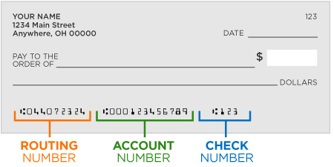

|  |
| --- |
| Signature:_______________________________________ Date:______________________________ |

**Please note:** Direct deposit will continue year to year. If you signed up last year, you do not need to sign up again unless your account information has changed.

Please fax completed form to SISCO at 563-587-5703, mail completed form to PO Box 389 Dubuque Iowa 52004, or email completed form to siscoflex@siscobenefits.com.