Private Pilot (FLI 131)

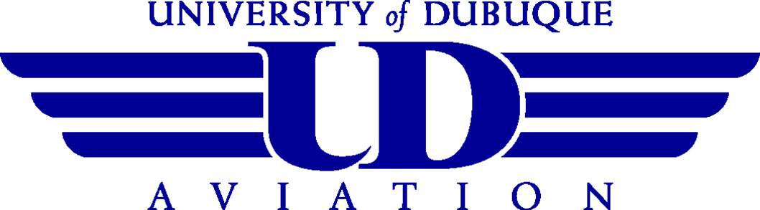
Includes
Expected Cost $17,175

60 Dual C172 $15,000
7.5 Solo C172 $1,515
2.5 AATD $250
10 Ground Instruction $410

Instrument Rating (FLI 231)

Includes

Fixed Wing Flight Cost Estimates
The Flight Center recently completed a review of the pilot ratings required to qualify for graduation. The expected cost in today’s dollars to qualify for graduation is approximately
$60,840. Students and their families should allocate a minimum of $15,210/year for flight training on a four-year flying program.

The Certified Flight Instructor rating is not required to qualify for graduation, but it is highly encouraged.

Expected Cost $ 10,210

32 Dual C172 $8,000
18 AATD $1,800
10 Ground Instruction $410

Commercial Pilot (FLI 132, 232, 334)

Includes
Expected Cost $ 24,750

36 Dual C172 $9,000
60 Solo Aircraft $12,120
24 AATD $2,400
30 Ground Instruction $1,230

Multi-Engine Rating (FLI 435)

Includes
Expected Cost $ 10,880

25 Dual DA42 $10,675
5 Ground Instruction $205

* Certified Flight Instructor (FLI 431)

Includes
Expected Cost $ 9,871

34 Dual C172 $8,500
1 AATD $100
31 Ground Instruction $1,271

Note: The prices for completion are the average hours of flight and ground instruction for each flight course. Based on historical data, each student progresses individually. Some students require more, some require less than the average hours of training to be proficient and able to pass their FAA check ride for a particular course.

* Certified Flight Instructor costs can be substituted for the multi-engine rating costs,
but are not added into the total for the Flight Operations Major.

