University of Dubuque
Course Proposal Form
Undergraduate Studies
Form Revised: October 2018

Click here to enter text. |  | Click here to enter a date.
Course Prefix, Number and Title |  | Effective Date/Semester
Note: If using this for course revisions please strike through words that are being deleted from previous proposal and use red lettering for any items that are new.
☐ New Course | ☐ Revised Course | ☐ Request Course be added to General Education Choices (optional: See Section C)

☐ Regular Grading ☐ Pass/Fail Grading
Describe rationale for the new/revised course:
Click here to enter text.
A. COURSE INFORMATION:
1. Major(s) or Minor(s) in which this course will be employed:(list clearly to help keep Aims up-to-date)
Click here to enter text.
2. Departmental Prefix and Course Number (Approval by Registrar Required):
(example: ABC 101)
Click here to enter text.
3. Course Title: (Full course name as will appear on transcript, 35 character limit)
Click here to enter text.
4. Abbreviated Title: (as appears on MyUD, 15 Character limit)
Click here to enter text.
5. Number of Credits: Click here to enter text.
☐ Fixed Credit (same number of credits each offering)
☐ Variable Credit (different number of credits each offering; i.e. Internship or 357 Topics courses)
Click here to enter text. Minimum # of credits
Click here to enter text. Maximum # of credits
☐ Cumulative Credit (course can be repeated without showing as repeat; i.e. HWS 110 or 357 Topics courses)
6. Capacity of Course: (number of students) Click here to enter text.

7. Description for the Catalog: (Include a clear and concise description of the course including the content of the course, the skills or knowledge the student will gain from the course, and a description of what the student would be able to achieve at the end of the course. Include any prerequisites for the course)
Click here to enter text.
8. Learning Time Worksheet Required (is the method of assessment proposed in section B of this document consistent with the details provided in the LTW):
☐ LTW Provided
Refer to this table for suggested reading speeds and complete LTW (found on page 6-7)
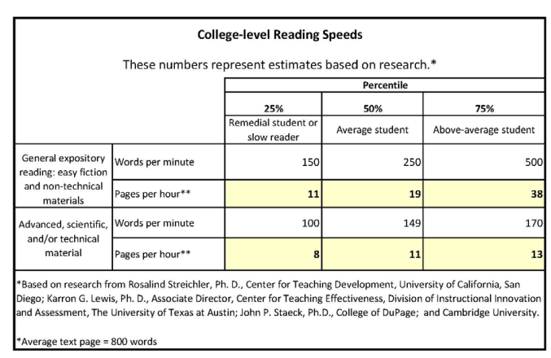

NOTE 1: The table above is taken from a similar "Credit Hour Calculator" which is used by Harding University.
NOTE 2: 250 words per minute is recommended as a standard average college-level reading rate. Consult the following web sites for further information:
http://www.sacrameducate.org/version2/pdf/Reading-Plus-Fluency-Chart.pdf
http://www.articlesbase.com/self-improvement-articles/determine-your-average-reading-speed-and-how-to-improve-it-1526986.html

B. LEARNING OUTCOMES AND ASSESSMENT:
Course: XXX XXX | Program (Student) Learning Outcomes  You only need to list the PLO’s that apply to this course. For PLO’s please indicate PLO number based on your departments PLO sequence/numbering
Course Learning Outcomes | PLO #: Click here to enter text. | PLO #: Click here to enter text. | PLO #: Click here to enter text. | PLO #: Click here to enter text. | Method of Assessment
CLO 1: Click here to enter text. |  |  |  |  | Click here to enter text.
CLO 2: Click here to enter text. |  |  |  |  | Click here to enter text.
CLO 3: Click here to enter text. |  |  |  |  | Click here to enter text.
CLO 4: Click here to enter text. |  |  |  |  | Click here to enter text.

*** Please insert or delete rows/columns and copy/paste the automated text fields as needed. In the center grid indicate if the CLO/PLO is an I (Introduce), R (Reinforce) or M (Master)
EXAMPLE:
Program (Student) Learning Outcome: Demonstrate the ability to recognize and apply ethical and professional excellence for responsible decision making
Course Learning Outcome: Demonstrate understanding and the application of the elements that make up operational safety including responsibility, accountability and ethical conduct in their chosen career field
Method of Assessment: Weekly journals and final ethics paper
Center Grid: I/R/M

C. GENERAL EDUCATION - ADDITION REQUEST: (Required only if the course is part of a General Education requirement)
1. General Education Listing: (example: Science w/ Lab, Fine & Performing Arts, Social Interaction, Intercultural Engagement, etc.)
Click here to enter text.
2. Rationale: (Provide a brief description of how this course meets the General Education requirement.)
Click here to enter text.
Approved for GENERAL EDUCATION CURRICULUM: ☐ Yes ☐ No

Chair – General Education Committee |  | Date

D. OPERATIONAL REQUIREMENTS:
1. Relationship of the course to other departments and programs, if applicable: (State how the course may function as a service or support course for other departments and/or programs. Include the names of Department Heads and other individuals that have been included in the discussion. Include a brief summary of those discussions.)
Click here to enter text.
2. Special Facilities: (Briefly describe the special facilities, such as science/computer labs, buildings or equipment, needs of the course.)
Click here to enter text.
3. Technology Needs: (Briefly describe the technology hardware or software, needs of the course.)
Click here to enter text.
4. Library Needs: (Describe any new or extraordinary Library resource needs of the course.)
Click here to enter text.
5. Budget Implications: (In addition to detailed staffing needs, explain the cost of the equipment or extracurricular activity expenses of the course.)
Click here to enter text.
6. Frequency of Offering and Projected Enrollment: (Identify how frequently and the number of sections each semester the course will be offered and how many students are expected to enroll.)
Click here to enter text.

E. DOCUMENT AUTHOR NAMES & APPROVAL SIGNATURES:

Document Author(s) Name(s): Click here to enter text.

Document Authors Signature: |  | Date
Department/Program Head Signature |  | Date
Coordinating Department/Program Head Signature* |  | Date
Chair – Curriculum Committee |  | Date
Vice President for Academic Affairs |  | Date
* Signatures do not have to be obtained at the time of initial submission to the committee. This is done AFTER the review and recommendation by the curriculum committee.
* Coordinating Department/Program Head signature required if another department will be impacted by a course revision or addition.

LEARNING TIME WORKSHEET
Course Name:
Instructions: Fill in the shaded fields below with the requested information. If necessary, clear the contents or enter the number 0 in the field if the type of learning activity described does not apply to your course. In completing this worksheet, estimate the time an average student will take to complete the listed activity. Actual time spent will vary widely based on individual student ability and motivation. This worksheet is intended to document that UD courses are designed to engage students in learning activities both in and out of class. This is not an evaluation of individual student achievement. Each student will need to demonstrate that she/he has met the learning outcomes of the course through the assessment methods developed by the department and/or instructor.
LEARNING ACTIVITY |  |  |  |  |  | HOURS
Planned In-Class Engagement
 | A. | Regular Class Sessions (Excluding Final Exam)
 |  |  | Total # of Sessions | Minutes per Session | = Minutes in Class | = Hours excluding final
 |  |  | 0 |  | 0 | 0.00
 | B. | Scheduled Final Examination Period (Required) |  |  | Minutes for Final | = Hours for Final Exam
 |  |  |  |  | 0 | 0.00
Planned Out-of-Class Engagement
 | A. | Reading Assignments |  | *Consult College-level Reading Speeds Table (attached) for suggested values
 |  |  | Level I | e.g. Advanced, Scientific, Technical or Scholarly Reading |  | = # of hours reading Level I Assignments
 |  |  | Total number of pages | Words per minute | Avg # words per page
 |  |  |  | 150 | 800
 |  |  |  | = Words per hour | = Pages per hour
 |  |  |  | 9000 | 11.25 | 0.00
 |  |  | Level II | e.g. Non-technical |  | = # of hours reading Level II Assignments
 |  |  | Total number of pages | Words per minute | Avg # words per page
 |  |  |  | 250 | 800
 |  |  |  | = Words per hour | = Pages per hour
 |  |  |  | 15000 | 18.75 | 0.00
 |  |  | Level III | e.g. Popular |  | = # of hours reading Level III Assignments
 |  |  | Total number of pages | Words per minute | Avg # words per page
 |  |  |  | 400 | 800
 |  |  |  | = Words per hour | = Pages per hour
 |  |  |  | 24000 | 30.00 | 0.00
 | B. | Other Out-of-Class Assignments (list/describe below): |  |  | Estimated Hours | = # of hours spent on Other Out-of-Class Assignments
 |  |  | Copy/paste additional needed copies of this row above
TOTAL AVERAGE HOURS OF ENGAGEMENT FOR THIS COURSE |  |  |  |  |  | 0.00
Minimum engagement hours: 1 CH = 37.5, 2 CH = 75, 3 CH = 112.5, 4 CH = 150

