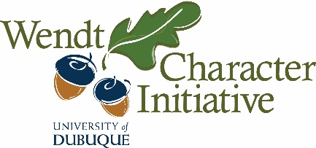
Wendt Character Initiative
Grant Request Form
All approved funding requests will require submission of receipts and/or invoices for reimbursements and a follow-up report. Please email to Wendt@dbq.edu. Please read separate instructions.

Name of Faculty/Staff Requesting Funding Department

Email Phone

Project/Event Name

Date of Project/Event

Will this project involve a class? If so, please include course name and number.

Other Sponsors/Potential Sponsors and Amount of Expected Contribution(s)

Itemized Costs (to your best knowledge)

Amount Requesting:
Brief Description of Project/Event
One sentence/phrase:
Elaboration: (Please attach any available supporting documents about the event or person; e.g. conference descriptions, bios, posters)
Fit with Wendt Character Initiative (How does this fit with, encourage, and/or build character, identified through integrity, justice, and/or compassion?)

How Project or Event will Impact and Engage Students (What specific activities will engage students, or how will students otherwise be impacted?)

Goals and Intended Outcome (What are your goals for the project/event? How do these connect to character knowledge and/or formation?)

Reflection Activity (for class) or Planned Means of Evaluating Effectiveness of Project/Event (How will you evaluate whether this project achieved your goals? What activities are planned for explicit reflection and/or discussion of how character is shaped by the experience or how character knowledge is expanded?)

NOTE: If your project/event is approved, please include the following language for public announcements of grants:
This project is supported by the Wendt Character Initiative, which is devoted to promoting a campus culture of excellent moral character and purposeful lives characterized by integrity, justice, and compassion.

________________________________________
FOR WENDT OFFICE USE ONLY

Amount Approved
Date Approved
Signature of Wendt Director

